**LAB 3**



Session: 2021 – 2024

**Submitted by:**

Muhammad Hamza 2021-CS-178

**Supervised by:**

Sir Laeeq Khan Niazi

Department of Computer Science

**University of Engineering and Technology**

**Lahore Pakistan**

**TASK 2**

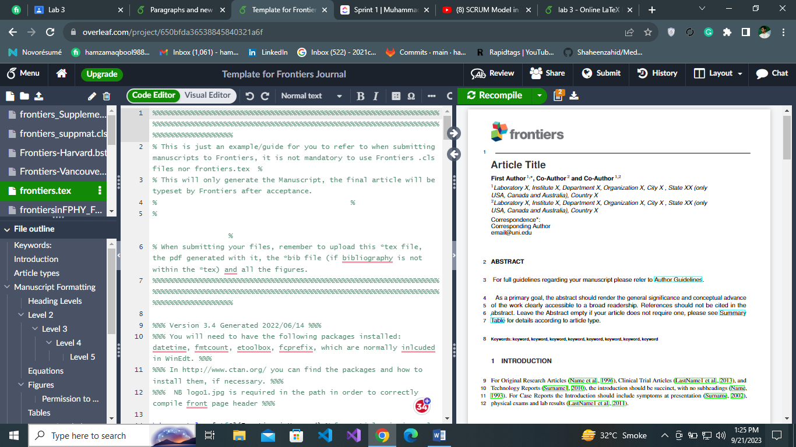

**TASK 3**

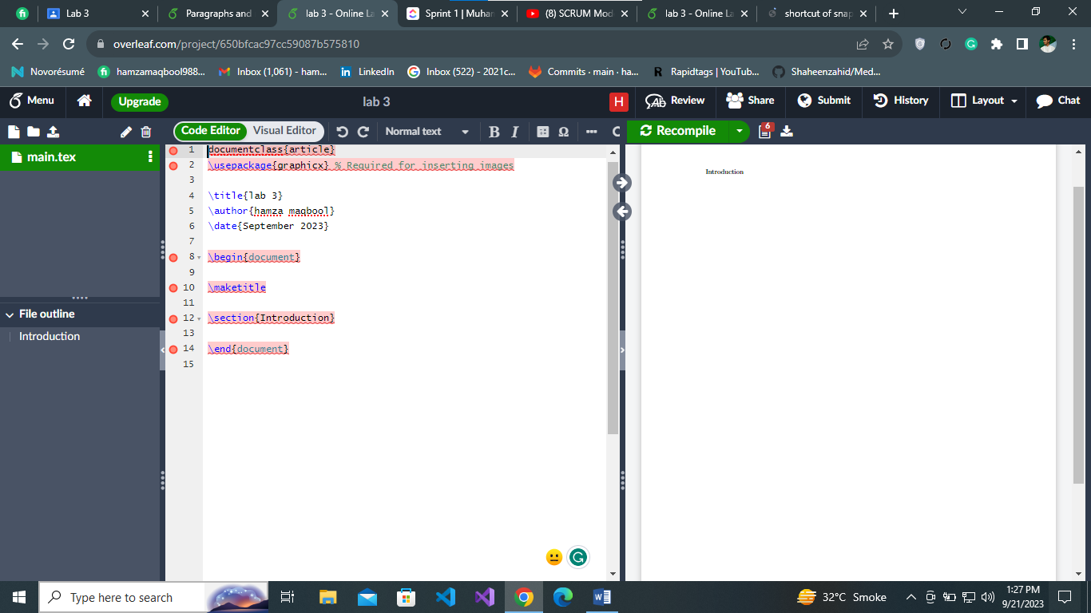

**TASK 4**

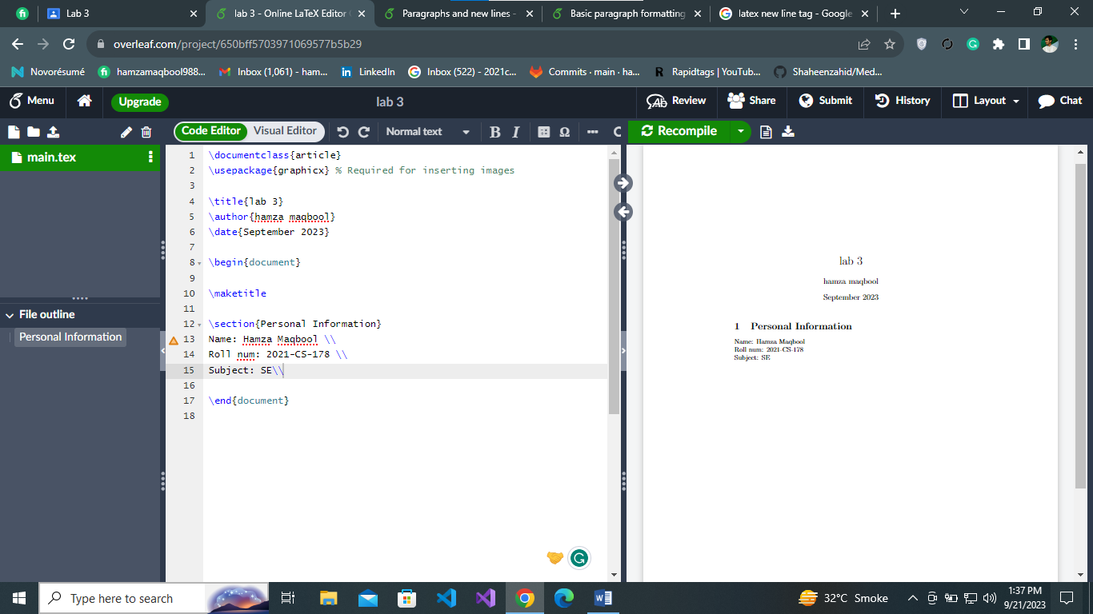

**TASK 5**

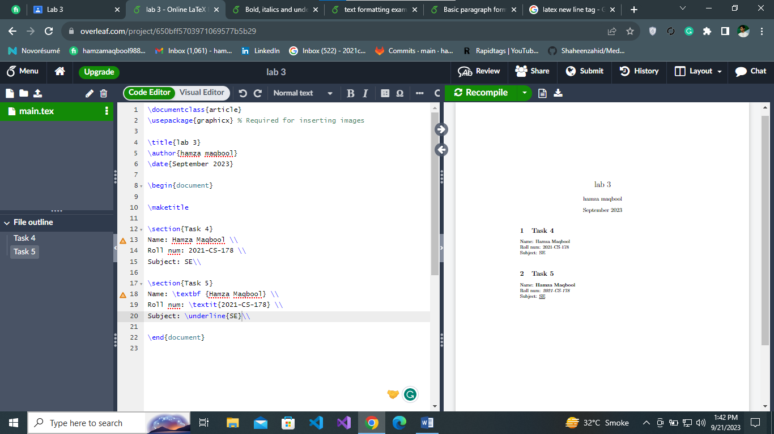

**TASK 6**

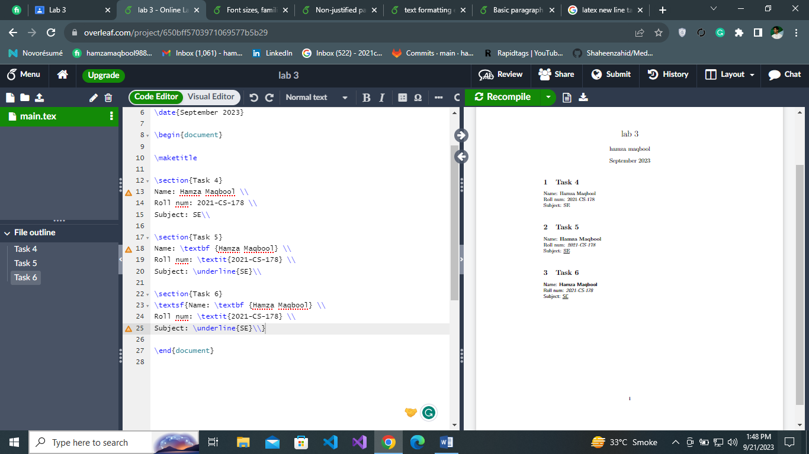

**TASK 7**

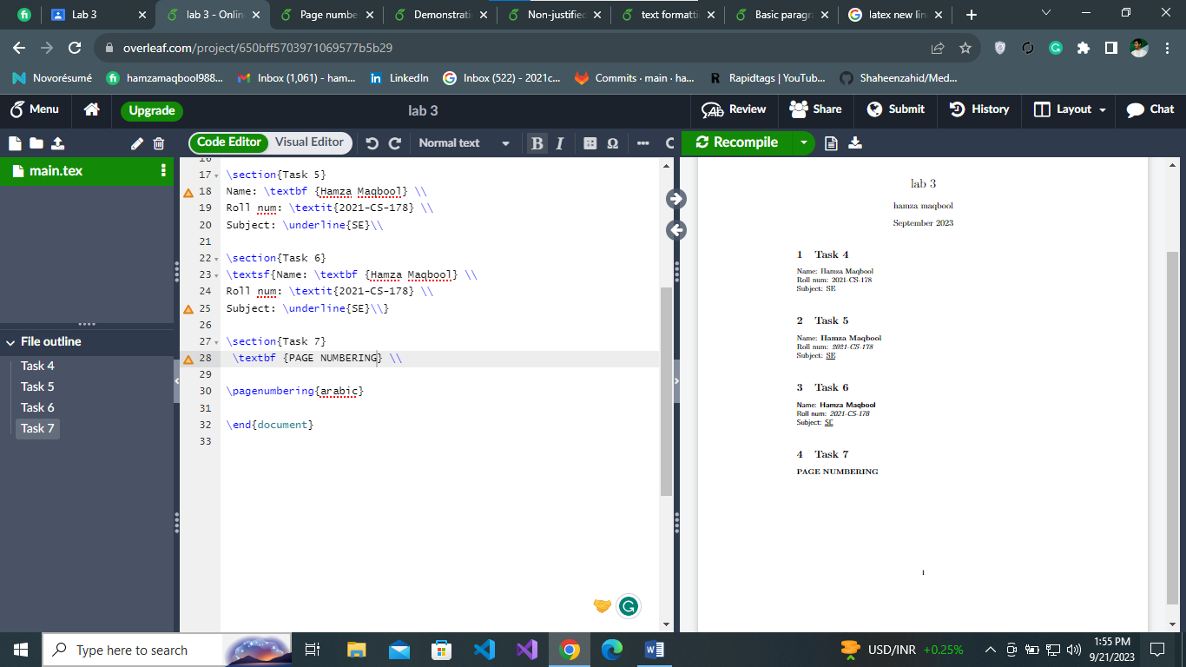

**TASK 8**

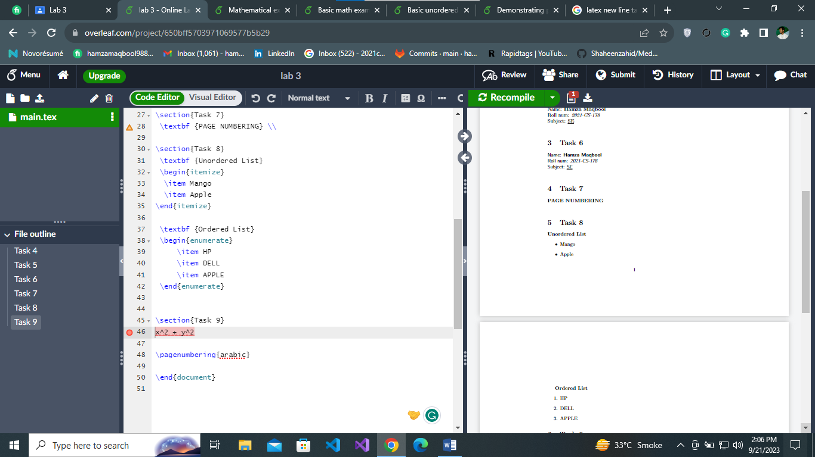

**TASK 9,10,11,12**

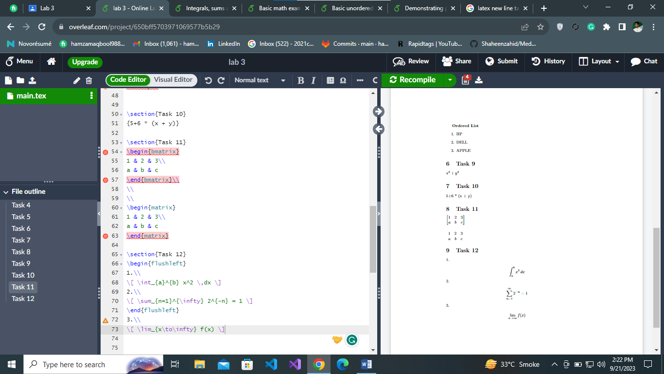

**TASK 13**

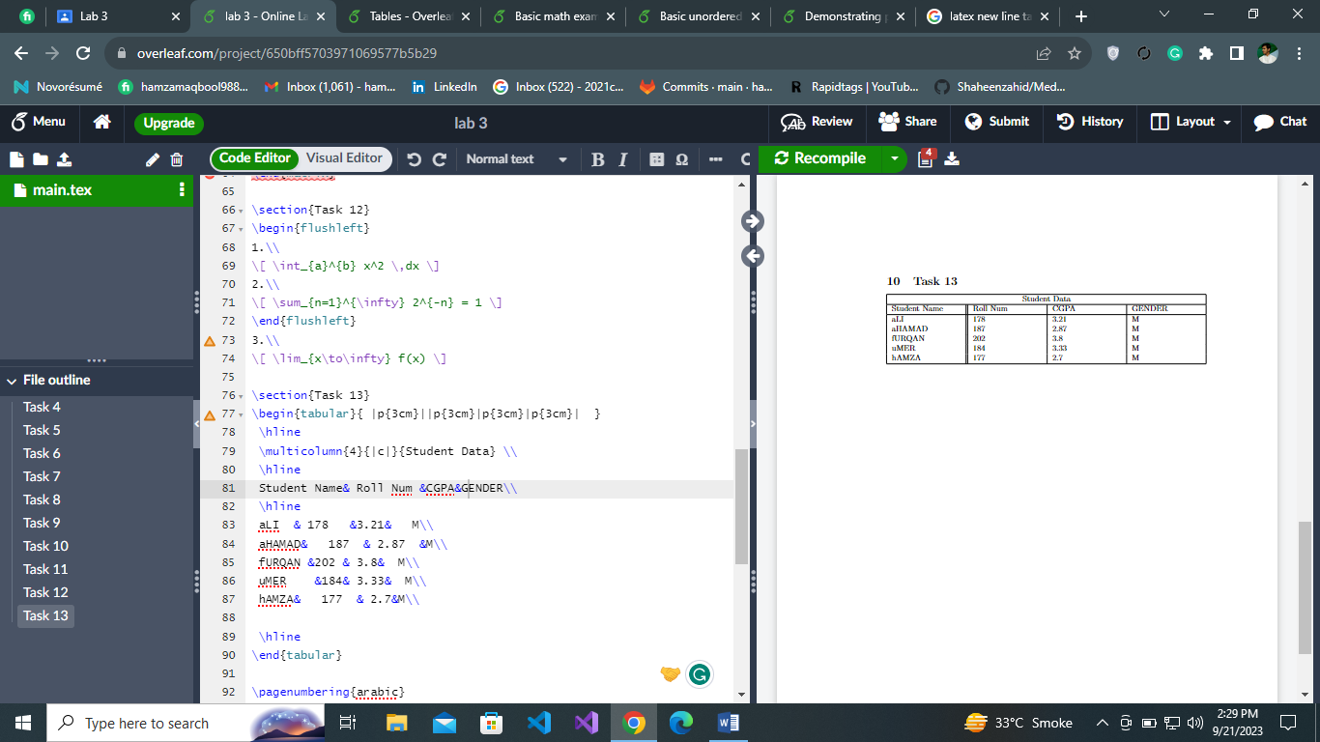

**TASK 14**

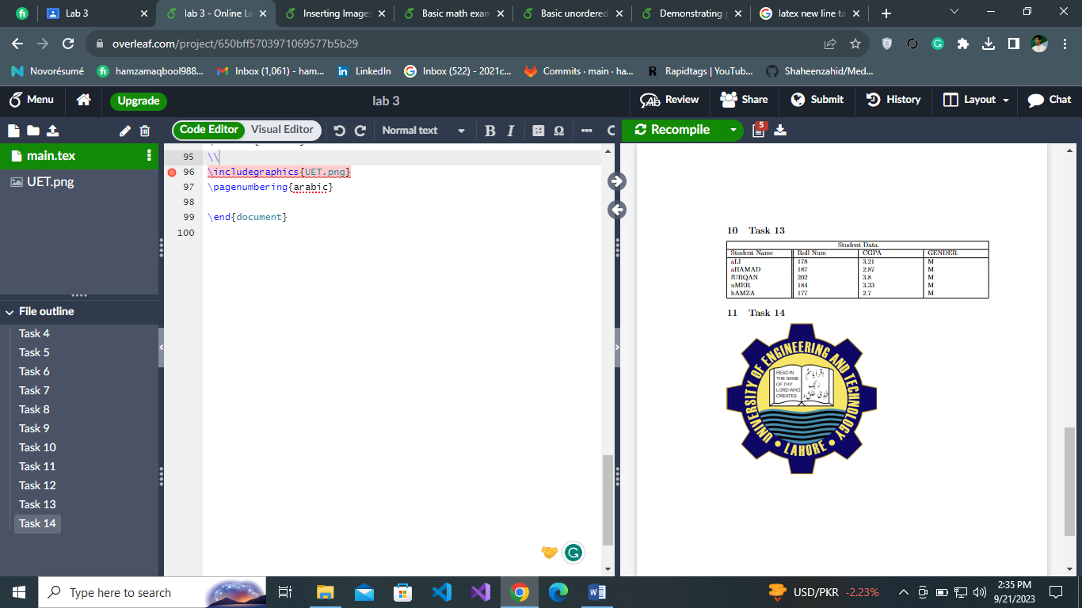

**TASK 15**

